**KEY POINT**

Bill Joy argues about the effect of technological advancements on society and presents an almost alarmist view on the consequences such technology will have on society as a whole. During the article he presents a view from Hans Moravec. “Moravec is one of the leaders in robotics research, and was a founder of the world’s largest robotics research program, at Carnegie Mellon University.”

He presents Moravec’s view on the effect of robotics on society, to try and predict the eventual consequences of the current technological advancements. Moravec argues about the clear dominance of robots over humans but that our own hope is that “Government coerces nonmarket behavior, especially by collecting taxes. Judiciously applied, governmental coercion could support human populations in high style on the fruits of robot labor, perhaps for a long while.”

The argument put forward by Bill Joy and Moravec is clear in this instance, robots will replace us due to their economic benefits. While Joy may not agree completely with Moravec’s view, it is quite clear that Joy considers Moravec’s vision as a likely version of the future. As Bill Joy himself is inexperienced in the field of robotics, the conclusion he puts forward is an amalgamation of ideas, such as those of Moravec.

It is quite clear that Moravec proposes a techno-utopian view that governments can re-distribute the benefits of technological advances. However, the evidence clearly shows the opposite:

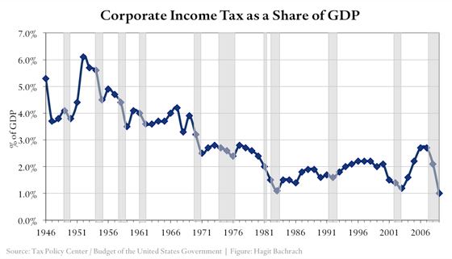

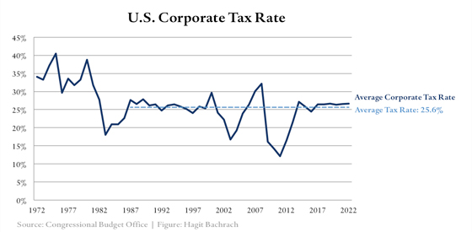

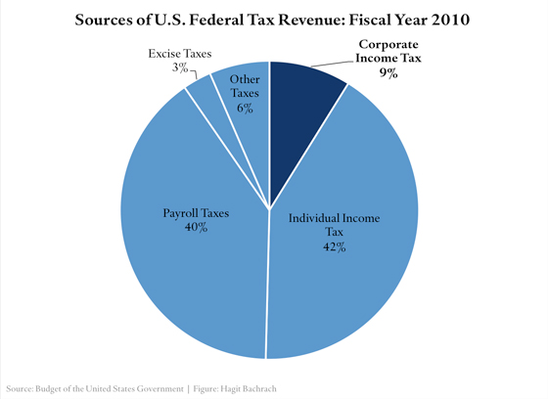

This shows the effective corporate taxes falling as percent of gdp as well as percentage wise. It’s quite clear the tax burden is falling on other sources rather than corporations.

We also see an interesting trend in income inequality:

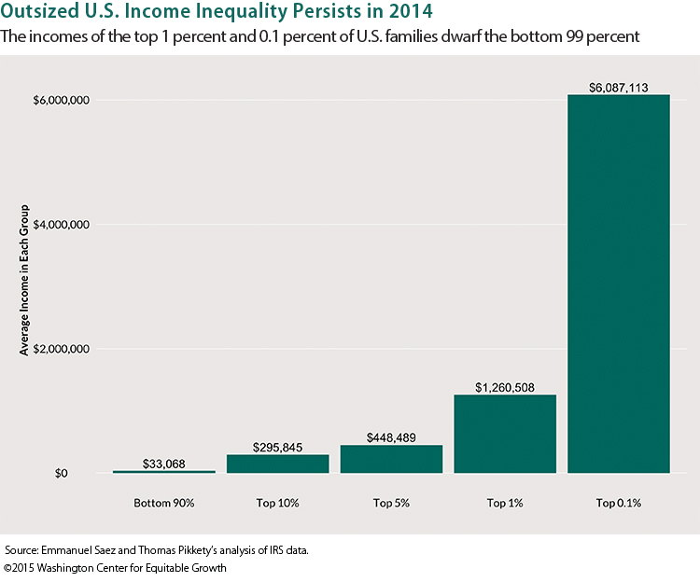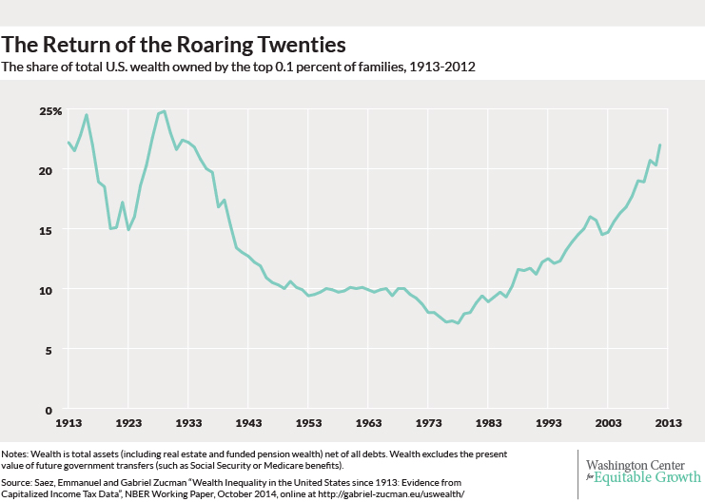

It’s clear that it’s difficult to re-distribute the income effectively to those who deserve it most due to economic and political reasons. The reality is that these rapid technological advancements may instead be throwing fuel to a larger fire and can once again spark the class conflicts that featured during the industrial revolutions.

**Sources:**

<http://www.cfr.org/united-states/us-corporate-tax-reform>

Tax Policy Center/Budget of the United States Government

Congressional Budget Office

Washington center for equitable growth.

<http://equitablegrowth.org/research-analysis/u-s-income-inequality-persists-amid-overall-growth-2014/>

**MY CONTRIBUTION**

As one of the Q&A’s it was my responsibility to have a more in-depth knowledge of each of the points presented in the pitch, so I could sufficiently explain and elaborate on any questions during the Q&A. This was achieved through a thorough reading of each member’s reports and communication which each member about their point.

I was also involved in finding info on the point about the replacement of human labour with machines and how societies currently re-distribute resources to the poor in society. I accomplished this by searching and sourcing info, stats and graphics to get a complete understanding of this topic.

Furthermore, I engaged with the team and team members throughout the process in forming our pitch. We discussed our pitch through a messaging client throughout our preparation period and met up occasionally to conduct a full survey of the current progress of our work. I was deeply involved in this process by asking questions and giving suggestions.